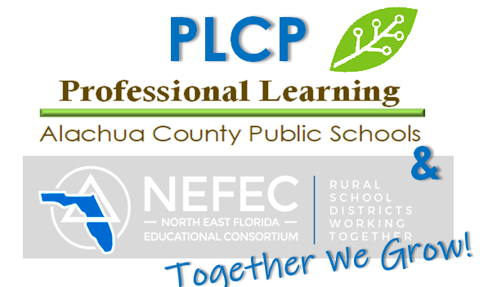

**P**rofessional **L**earning

**C**ertification **P**rogram

# **How can I shape my future?**

# **ACPS Teachers**

# **If you have …**

* A bachelor’s or higher degree
* Content expertise in a field of study
* A love of learning
* Skill in motivating others
* A desire to work in a dynamic environment

…then the PLCP path to professional certification could be right for you!

**Start today!**

You do not have to complete college education courses in order to teach in Florida. If you qualify for a Temporary Florida Educator’s Certificate, you can begin teaching now. While teaching, you can learn the professional education competencies to qualify for a professional Florida Educator’s Certificate.

**Here’s how …**

* **Apply and qualify for a Temporary Florida Teaching Certificate**
* **Be employed in the Alachua County school district as a teacher**
* **Apply to enter the Alachua’s Professional Learning Certification Program**
* **Attend the PLCP Orientation for an overview of the program and to establish your support team.**

**Answers to your questions …**

**What does “professional learning certification program” mean in Florida?**

* On-the-job training in professional education competencies—the Florida Educator Accomplished Practices
* An alternative path to satisfy professional preparation requirements for a Professional Educator’s Certificate

**PAGE TWO**

**Will my Florida Educator’s Certificate be the same as the one earned by education majors?**

Yes. Completion of the Professional Learning Certification Program, along with other eligibility requirements, results in the same Professional Educator’s Certificate.

**What are the Florida Educator Accomplished Practices?**

The FEAPs are the research-based knowledge and skills that all Florida teachers need, regardless of what subject they teach, so that their students can master the skills delineated by the Florida Standards for students. The six Educator Accomplished Practices address:

1. Instructional Design and Lesson Planning
2. The Learning Environment
3. Instructional Delivery and Facilitation
4. Assessment
5. Continuous Professional Improvement
6. Professional Responsibility and Ethical Conduct

**Does the PLCP require college courses in education?**

No. The program is competency-based with no college coursework required. You will complete 20 tasks, many of them right in your classroom with your own students, to submit as evidence that you have demonstrated competency with each of the Educator Accomplished Practices. You will also complete Reading Endorsement Competencies and pass the Professional Educator Exam.

The requirements for the program include:

* Complete all PLCP assignments satisfactorily
* Complete coursework to satisfy Reading Endorsement PLCP requirements
* Pass the Professional Educator, General Knowledge, and Subject Area Examinations
* Remain employed as a teacher during the time in the program

**How do I work within the program?**

The PLCP learning activities and tasks are housed in an online course which is accessed through any computer with internet access.

**Self-directed!** Your online instructor will give you a model schedule that you may follow. You should plan to devote a minimum of five hours a week to your PLCP work. Many of the tasks will be started at the beginning of a semester and continue for several weeks as you work with your students to gather resources, create lesson plans, plan parent conferences, analyze your students’ learning, and complete other required activities included in the program.

**How long will it take me to complete the PLCP?**

Many participants can complete the program in one full year—two semesters plus summer work. Some teachers, however, choose to extend their work over a two-year period or even longer, but **requirements must be completed prior to the expiration of your temporary certificate.**

Your district may give you a targeted completion date.

**What are the PLCP semester dates?**

PLCP Semesters:

* September-January (FALL)
* January -May (WINTER/SPRING)

**How much does the PLCP cost?**

**$700 per semester**. Typically, it takes two semesters to complete the online modules.

**PAGE THREE**

**Payment of Participation Funds:**

* The fee to participate is $700 per semester (fall, spring) using ACPS payroll deduction.
* PLCP Semesters run September -January (FALL) and January-May (SPRING)
* [Payroll deduction](https://drive.google.com/file/d/1EkX7WZb9Z7LJqi7eNrq_KfetDKeLszGr/view?usp=sharing): $175 X 4 Paychecks = $700/Semester
* **Submission of payroll deduction form OR check is REQUIRED to begin coursework.**
* **Each semester, participants will need to complete a new payroll deduction form or check.**
* A participant may decide not to participate after beginning the program. **Decision NOT TO PARTICIPATE and be removed from the current semester MUST be submitted by email to Mrs. Emma within two weeks following the beginning of the semester.**  **Participants who drop or remain inactive after the two-week drop period will owe the semester fee.**
* **Charter school teachers only- payment must be remitted to the PL Office by check**

**How does the Mentor-Mentee partnership work?**

* Mentors must be:
  + rated as effective or highly effective on their annual performance appraisal
  + recommended by the principal
  + have completed Clinical Educator training
  + attend a PLCP orientation
* PLCP participants are expected to meet regularly with their mentors for support and advice. Mentors are selected to provide help with explanation of task directions, editing, organization, motivation, and encouragement.
* It is expected that the mentor and mentee will develop goals at the beginning of the mentoring relationship and will evaluate those goals periodically. While the mentee is expected to consider the advice of the mentor, ultimately the mentee must make his or her own decision whether or not to accept and/or act on the mentor’s recommendations.

**Visit these Florida websites:**

Florida Department of Education Bureau of Teacher Certification

<http://www.fldoe.org/teaching/certification/pathways-routes>

Florida Alternative Certification

<https://www.altcertflorida.org/>

**For more information about ACPS Professional Learning Certification Program:**

**Raysa Emma**

Supervisor

(352) 955-7628

Email: Emmar@gm.sbac.edu

Professional Learning Certification Program Coordinator